Analysis

**1.1- Introduction:**

For my NEA project, I have decided to create a news managing service that uses machine learning and natural language processing to categorise, detect sentiment and present the news to the user from many different news agencies, medias and sources. My news service strives to surface news efficiently to the user by preventing clickbait, information overload and fake news through the use of certain algorithms and through the use of many agencies for accuracy. The user will be able to access all global news from all sources instantaneously from one site.

A generic news site aims to present the most recent, newly discovered and interesting news stories that to the user, at any given moment. The news is filtered into categories, so that the user can view what they are most interested in, as well having an option to display the most popular and hyped news at the time, which is often determined though popularity on social media.

My target audience for my news site is everyone, however I will be concentrating more on the younger audience, such as students. I will add specific features to make it appeal to the youth, and when finished, I will test in on a large group of people ages 17-40.

My aim for this project is to learn how to use the most modern and useful machine learning algorithms, and how to train my machine learning model for data prediction and classification. I will also be learning how to use natural language processing to manipulate and change or summarise text, and how web scrape, and use a Twitter firehose. On the front end side, I will learn how to use html and css to create a user friendly GUI, using efficient methods.

**1.2 - Investigation:**

Existing News Sites:

**Google News:**

Google news is a new aggregator that compiles news articles from over 20,000 news sources (4,500 in English) to show a wide spectrum of news stories, sources and political views to its users.

To display the news to the user, Google News uses tables to present news headlines that were written by different newspapers and sources. Each headline acts as a link to the following story, that, when clicked, sends you to that page. The news is all categorised in 9 categories:

1. UK
2. World
3. Local News
4. Tech
5. Entertainment
6. Sports
7. Science
8. Health

Google News also presents a customisable timeline of different news articles that consist of a headline and a summary text taken from the article. The full article is also linked in case the user wishes to read on. Using JavaScript technology, the user can drag and drop elements on the page to tailor the feed to their personal desires, through the selection of different locations worldwide (local or otherwise) and different topics (for example tech, business, etc.).

Google News additionally has a favourite feature that lets you remember your favourite articles, newspaper agencies and sources. To personalise your account even more, Google News analyses your Google Searches and Social Media use to find articles most interesting and appropriate to you and shows 5 articles daily in the ‘for you’ section.

Overall Advantages:

1. Google News lays out multiple news stories from different agencies, reporters and journalists and provides a variety of political viewpoints.
2. Google News Uses over 20,000 news sources
3. Displays a customisable timeline with different news summaries and headlines with a link to the original article
4. News can be customised to the users desires, through the selection of different locations worldwide (local or otherwise) and different topics.
5. Google News is available as an application and a website
6. Goolge News allows you to share stories via social media (Twitter, Facebook)

Overall Disadvantages:

1. Google News does not create summaries on text by analysing the original text, it only transports you to the original page
2. Logins are mandatory and there is no way to check the news without creating an account

Screen Grabs:







In my project I am planning to use stories from multiple agencies just like Google News. I am however also planning to provide a summary of each article that I will create using natural language processing, which is something that Google News doesn’t do, but browsing it inspired me to add it to my project. I am also planning to provide news from many geographical locations like Google News where you can view UK news, Global and anywhere else. Additionally, I will cut down filler from headlines to make them more to the point and decrease information overload, a feature that Google news does not as successfully as I want to.

**BBC News:**

BBC News provides a large number of relevant news articles and sources on more than 12 specific categories that include:

1. UK
2. World
3. Business
4. Politics
5. Tech
6. Science
7. Health
8. Family
9. Entertainment
10. Video

It is the world's largest broadcast news organisation and generates about 120 hours of radio and television output each day, as well as online news coverage.

BBC News allows its users to create an account that is linked with the net of BBC channels to help you find news relevant to your geo location. BBC News additionally has a category for videos that are often taken from the BBC documentaries themselves, which gives them a wide variety of educational short and long videos. Its worldwide popularity, excess content and TV channels give BBC News a very good reputation, making it known to be extremely reliable and very successful at representing UK and global events.

BBC News also features a Brexit wordcloud. The wordcloud was highlighting the most common words Tweeted to do with Brexit by UK’s MEPs. The most common words are displayed in a larger font and bolder colour, compared to the lesser common words. This shows that BBC News also takes in account social media and its influence on global events.

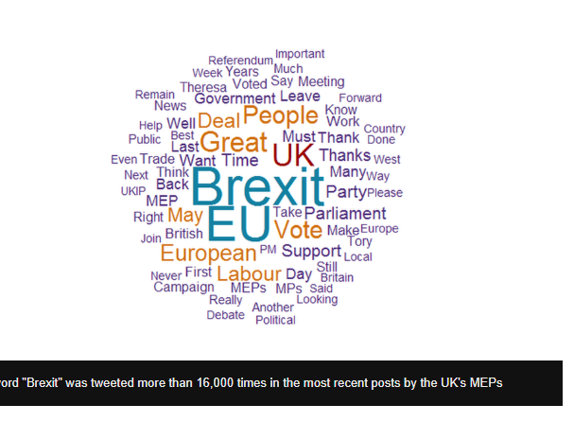

Overall Advantages:

1. BBC News has a very good reputation because of the age and success of the company.
2. Has as many as 10 categories and includes many education videos and documentaries
3. Has the budget to feature a lot on its news channel (e.g. wordcloud) and website and has more influence of Television due to the net of BBC channels.
4. Features articles from over 2000 journalists from all over the world, meaning that only the best articles end up being posted, with well written summaries.
5. Has a most watched feature at the bottom of the page
6. Uses social media input in some of its articles
7. No required logins

Overall Disadvantages:

1. Only uses BBC as a news source
2. Does not have personalised sections
3. No favourites feature

Screen Grabs:





Overall, I am planning to use BBC News as one of my main news sources, I am also planning to have around 10 categories and I will feature a wordcloud due to its originality and efficiency in portraying the news to the user. I am also planning to use social media in my site to improve its liability like BBC news.

**TweetDeck:**

TweetDeck offers extremely modern technology for a good user experience by including real-time updating and advanced searches and filters. The interface is based around columns and you can have as many of them as you want for your main timeline, lists, notifications and specific searches. All of your columns can have certain words matched or excluded, and they can be limited to specific users (like your team's accounts) if necessary.

The design has its advantages of easy scrolling and a simple familiar interface however, doesn’t use a wordcloud which is more original and it gives a more visual representation of news and it allows the user to absorb all the news on the page at once without having to deal with timelines. Having TweetDeck always personalised based on your previous searches is useful, as it will mainly show the news that interests you, however it means constant bias that you can’t turn off.

TweetDeck additionally allows the use of accounts, which is useful as all data is saved and you can subscribe to wanted news channels, but on the other hand, it gives you no choice to not personalise your account and time is wasted during login. It also additionally uses notifications and messages for further discussion of the news and the ability to directly message/tag a news channel,

TweetDeck news site uses the media for validation and approval from the public to reduce bias (that could benefit large profitable companies or political outcomes

Overall Advantages:

1. Notifications and a messenger available
2. Real time updating
3. Timelines included
4. Links to social media
5. Unlimited columns for an easy familiar layout with no limitations.
6. Global filters can help filter your wanted stories, you can choose to avoid and focus on tags
7. You can post things on several accounts at once
8. Media and comments are used for approval on TweetDeck to help reduce bias and fake news
9. Ability to personalise your account with profile pictures, saves columns, status updates and tweets.

Overall Disadvantages:

1. Only uses Twitter as social media
2. Has only a few original features that differ from Twitter
3. Has mandatory Logins and you are unable to use the site without a Twitter account
4. Uses columns for news layout, a commonly used unoriginal interface

Screen Grabs:







I am planning to also use a social media platform, like TweetDeck and I will offer Global filters and links to news stories and like TweetDeck. I am also inspired by the colourful GUI but am planning to use a wordcloud instead of tables for a more modern experience.

Questionnaire:

To help me make more decisions on how to implement my site, I will induce a questionnaire on the more problematic aspects of the site. As my target audience is mainly young people I will try to add features appealing for the young generation for a greater sense of inclusion in the news world. The questionnaire was done by both teens and adults, to strive to perfect the user experience, by considering and listening to the feedback. The questionnaire was done by 75 individuals, ages 16-40, for evenly distributed results. The questions are as follows:

**How often do you check the news?**

This question was created to understand whether a News App would be in interest of most people and whether it is relevant to the current global situation. Knowing the frequency of news checking also gives be a better understanding of my target audience and helps me decide on what features should be included.

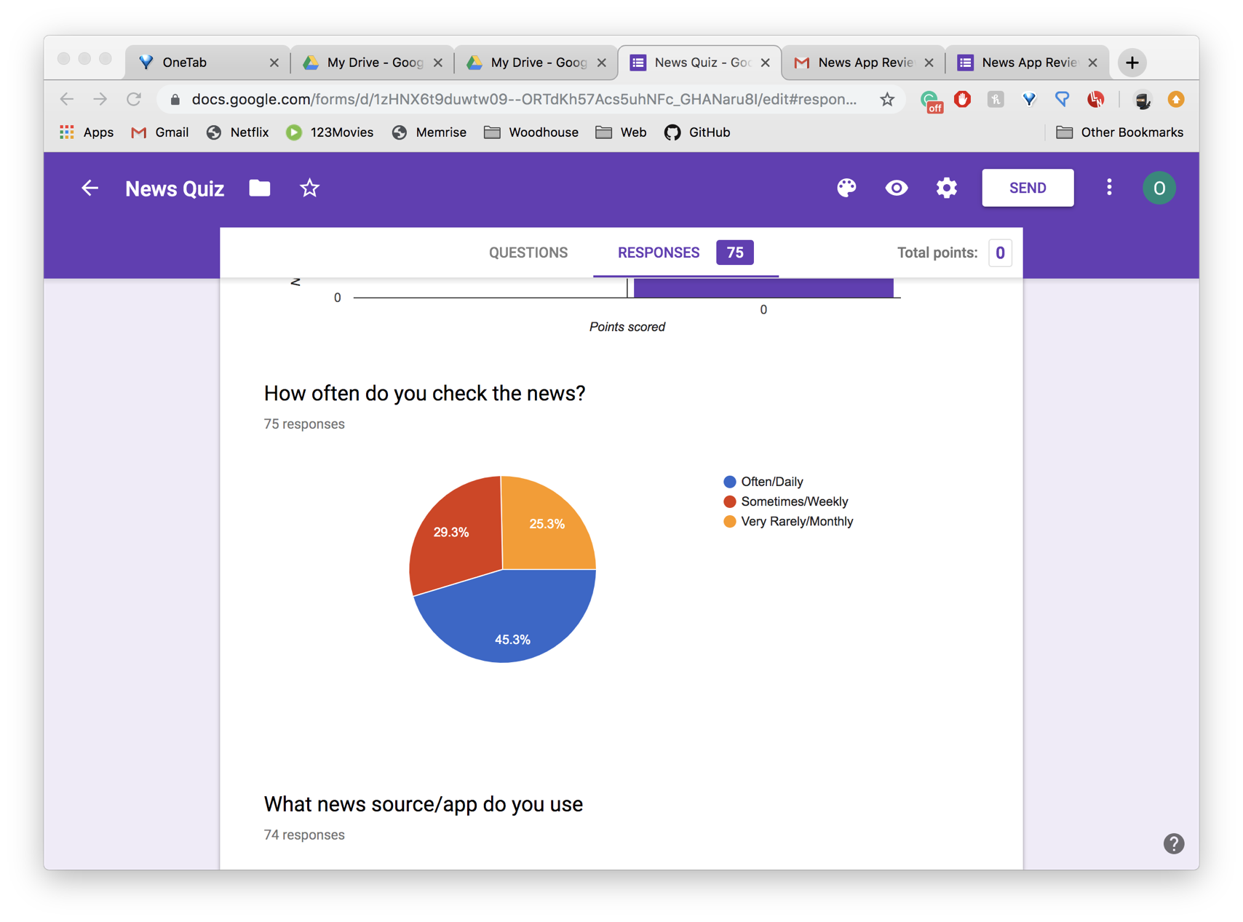

The overall response was very positive, with 45.3% checking the news daily and 25.3% weekly. This means that around half the target audience have news checking as part of their daily routine, therefore, _______ must update the news very frequently through the day to improve the user experience.

**What news source/app/site do you sure the most?**

This question was created to understand the main competitors of _____ as well as understanding which sources ______ should consider referencing in its “multiple source feature”, by understanding which sources/apps have gained a successful reputation across my target audience.

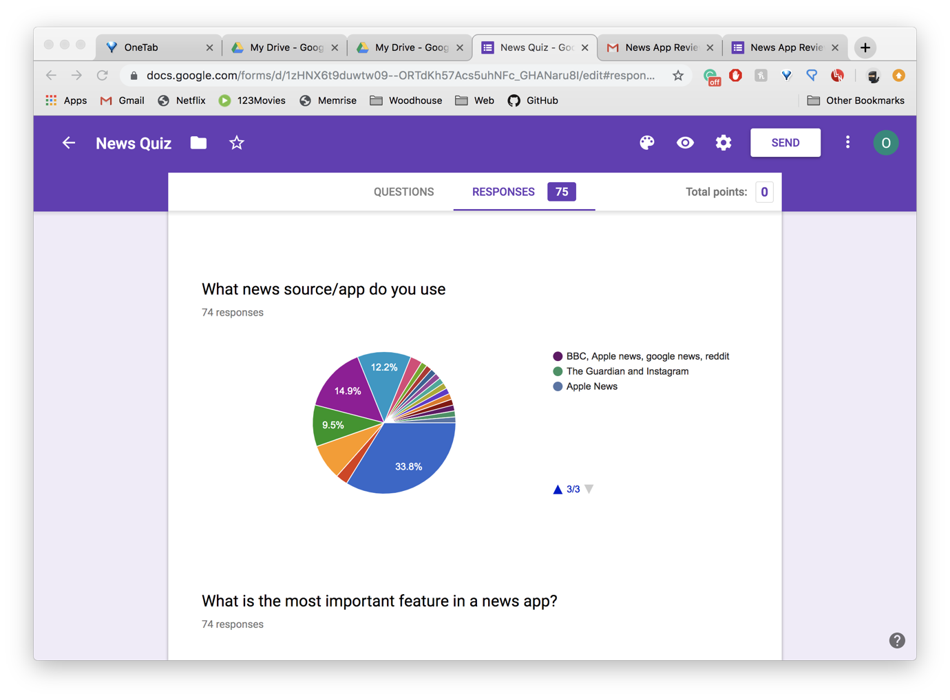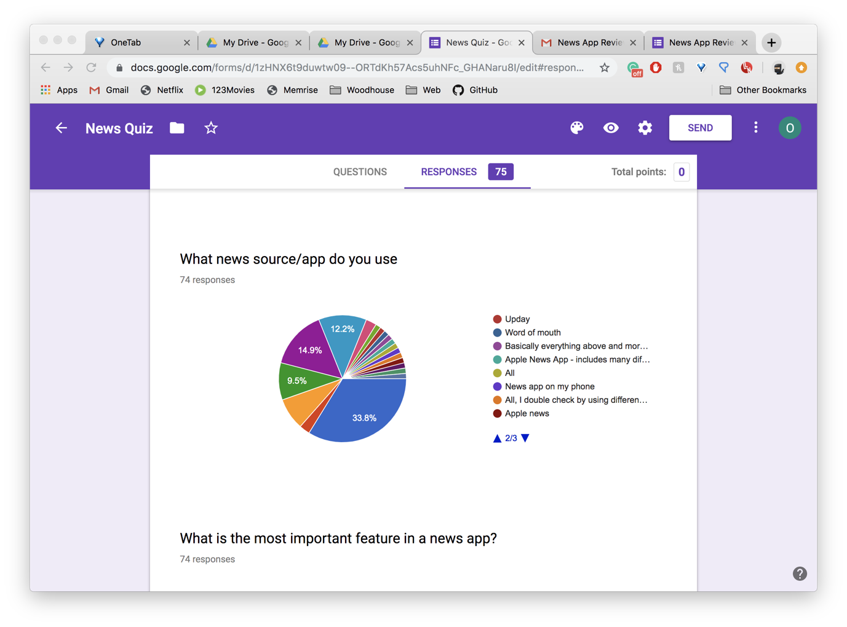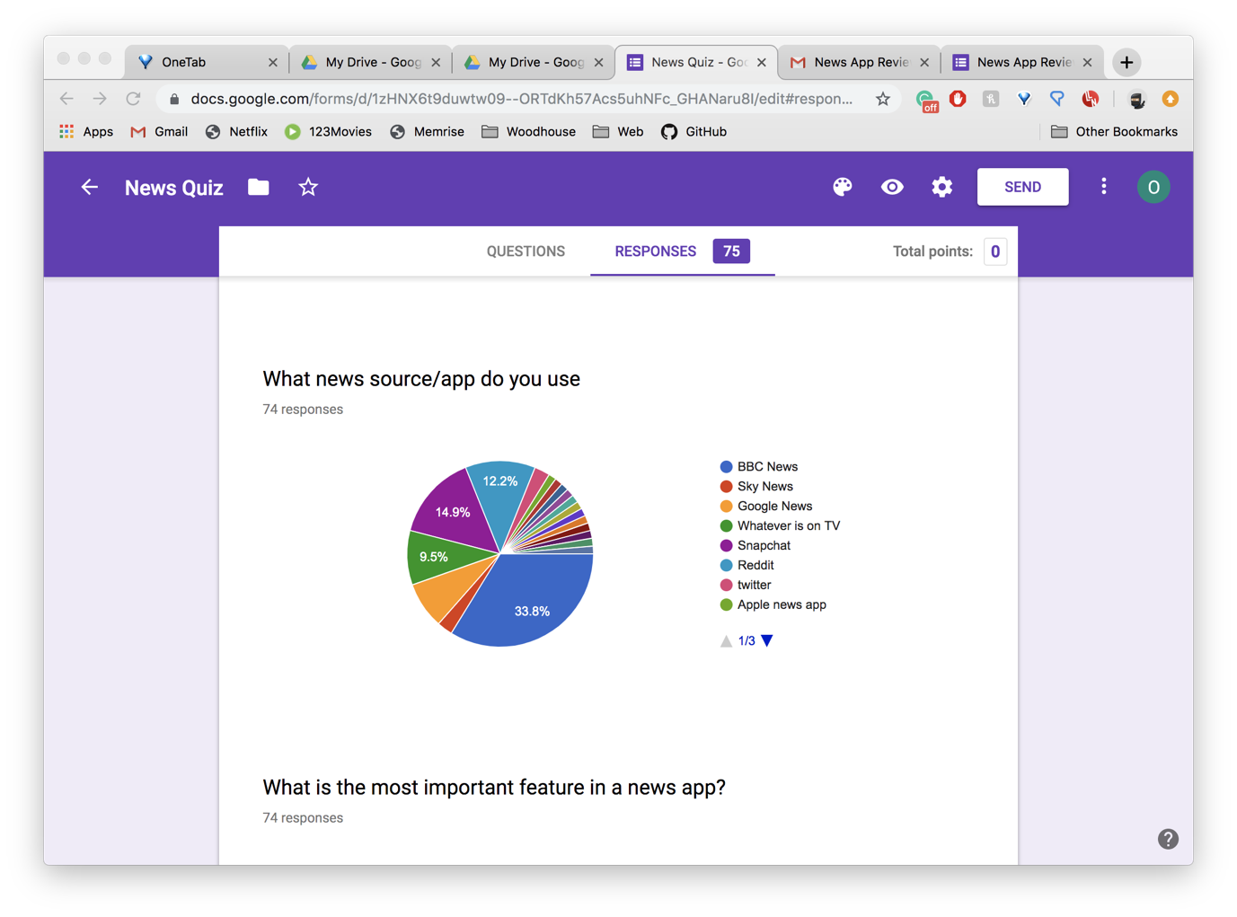

The results for this questionnaire ended up being rather messy, as not enough news options were included originally but after sorting out my data neatly, I created a more accurate pie chart that gave me a better representation of everyone’s favourite news source.

After filtering my results, I got a better representation of my competitors. My main competitor by far was BBC News because of its good reputation and credibility. After analysing BBC News, I realised that makes it such a strong competitor. It is its successful reputation, many categories, featured articles, videos and social media input. I must design my News site to it can be a strong competitor against BBC news to including unique features that BBC News does not include. (page 4)

**What is the most important feature of a News Provider/Application?**

This question was created to understand what features, my target audience will look for in a successful news provider and whether providing multiple sources and condense summaries are successful ideas.

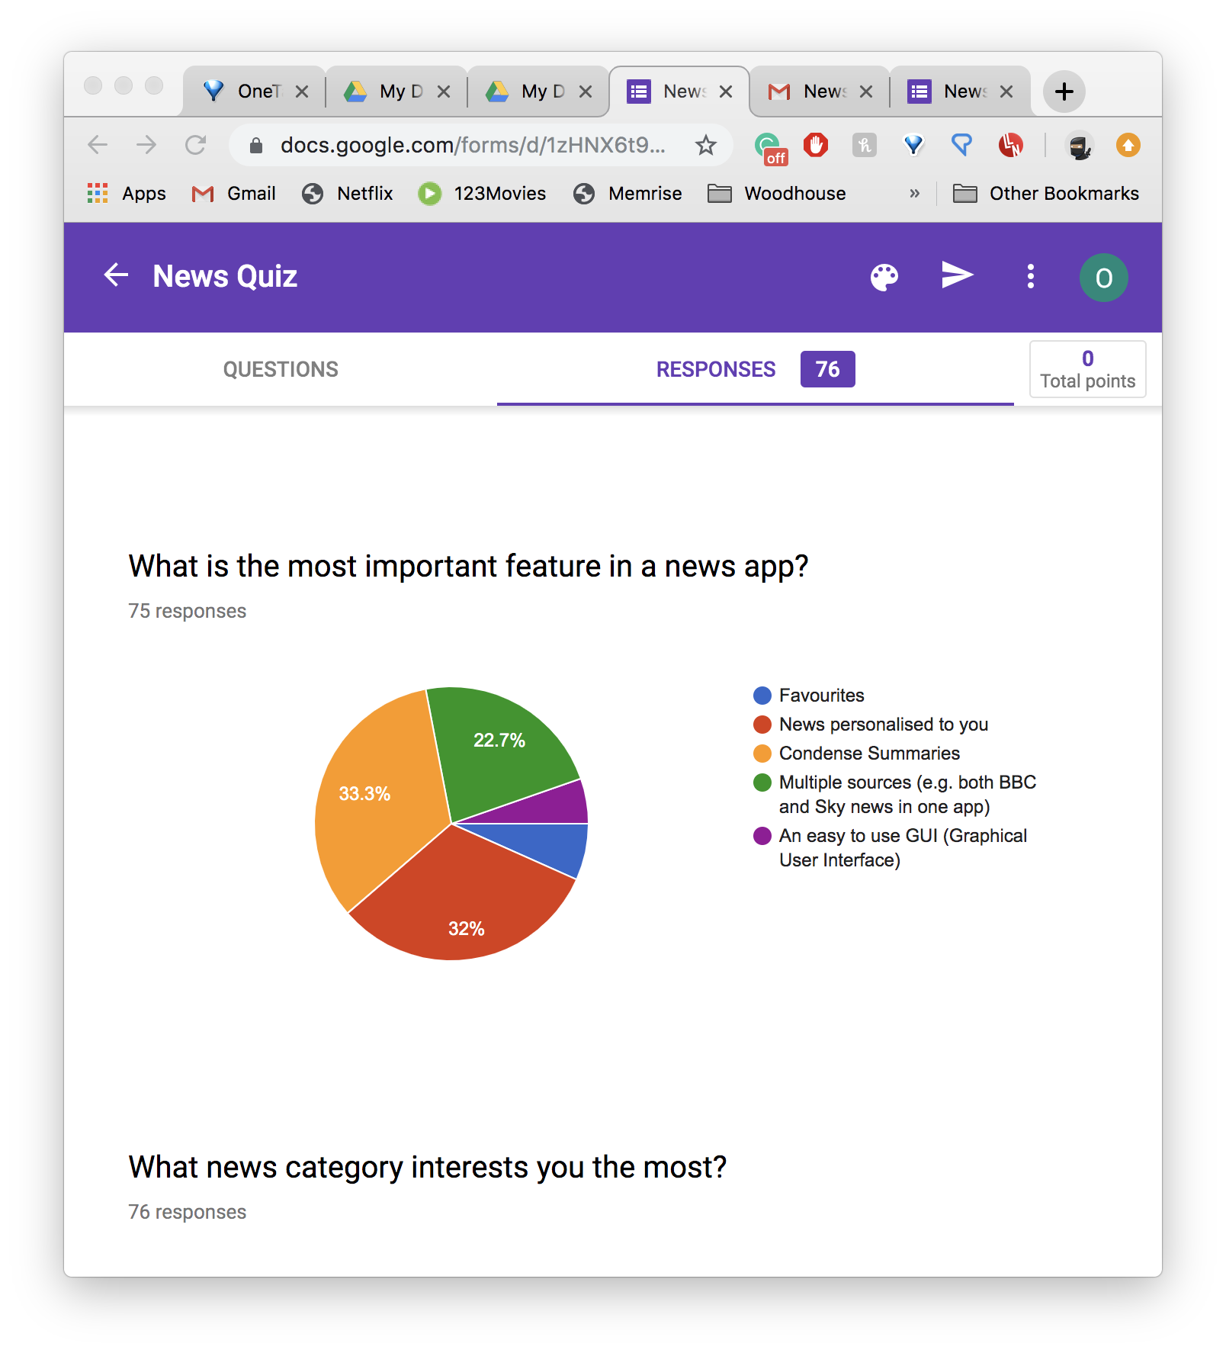

The results were very positive again as both condense summaries (33.3%) fro both tedt and headlines, and using multiple sources (22.7%), got high interest percentages, making them successful decisions for _____ development. Personalised News was also rated very highly meaning that I must either consider adding in that feature of I will need to come up with strategies to overcome the competition. Adding the personalised News means I must add an accounts feature. To help me decide whether an account feature is a good idea I also used it as a questionnaire question.

**Would you prefer to have an account in your News App or make all News available without accounts?**

This question was created to understand whether my site needs a login page that contains accounts or whether is it better to make no accounts meaning no features such as favourites or personalised news or logins.

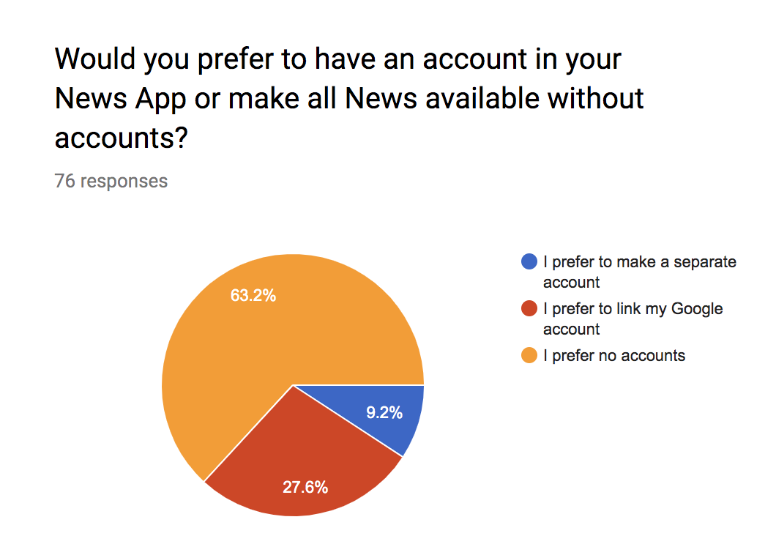

The public reacted strongly to no accounts as” accounts are take too long to manage and logging in takes too long”. This therefore means I should not create separate accounts but that also means I am unable to add features such as favourites or recommendations. Favourites and personalisation is used by Google News and Tweet Deck (pages 2-5), and they make it very efficient, so without accounts it will be harder to compete with them, however I cannot act against my target audience and to make it most useable for the youth, I must concentrate on condense summaries feature and multiple sources.

**Is it useful useful for a News service to link to social media?**

The next step is to understand whether Is it the more popular decision to want to link social media to a news service of whether a very useful feature to the public is not.

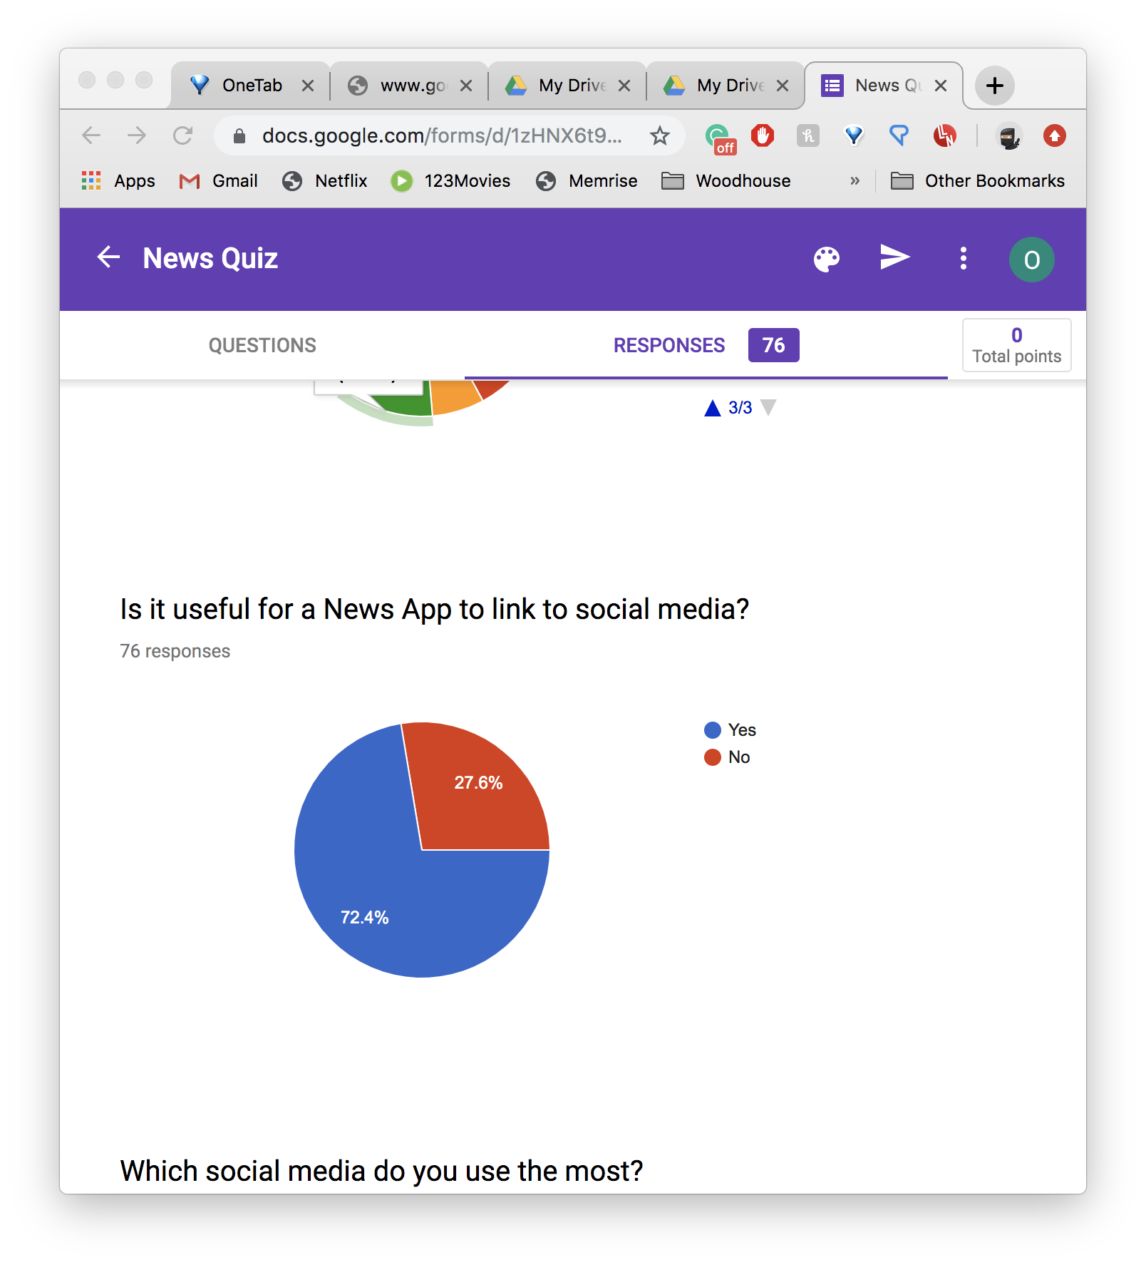

A large majority voted for linking social media to a news service therefore I have decided to link a social media platform to ______ to appeal to the public, similarly to BBC news and TweetDeck.

**Which social media platform do you use the most?**

I created this question to decide with platform I should link to _____ based on which platform is most commonly used by the public.



The results predicted that around 35.5% use Twitter and it was chosen as the most used platform, therefore I must consider connecting Twitter to news service. Twitter can be useful as I can introduce hashtags to ______ and can also check reliability of the news by observing the reaction of it on Twitter, to make my news service more reliable, with less fake news. I can also help comments and likes to distinguish the most popular news at any given moment.

**What news categories interest you the most?**

This question was created to see which news categories the most vital ones are to include. It was also done to see which categories the public and the youth would connect with the most, and what categories promote awareness and inclusion to the public.

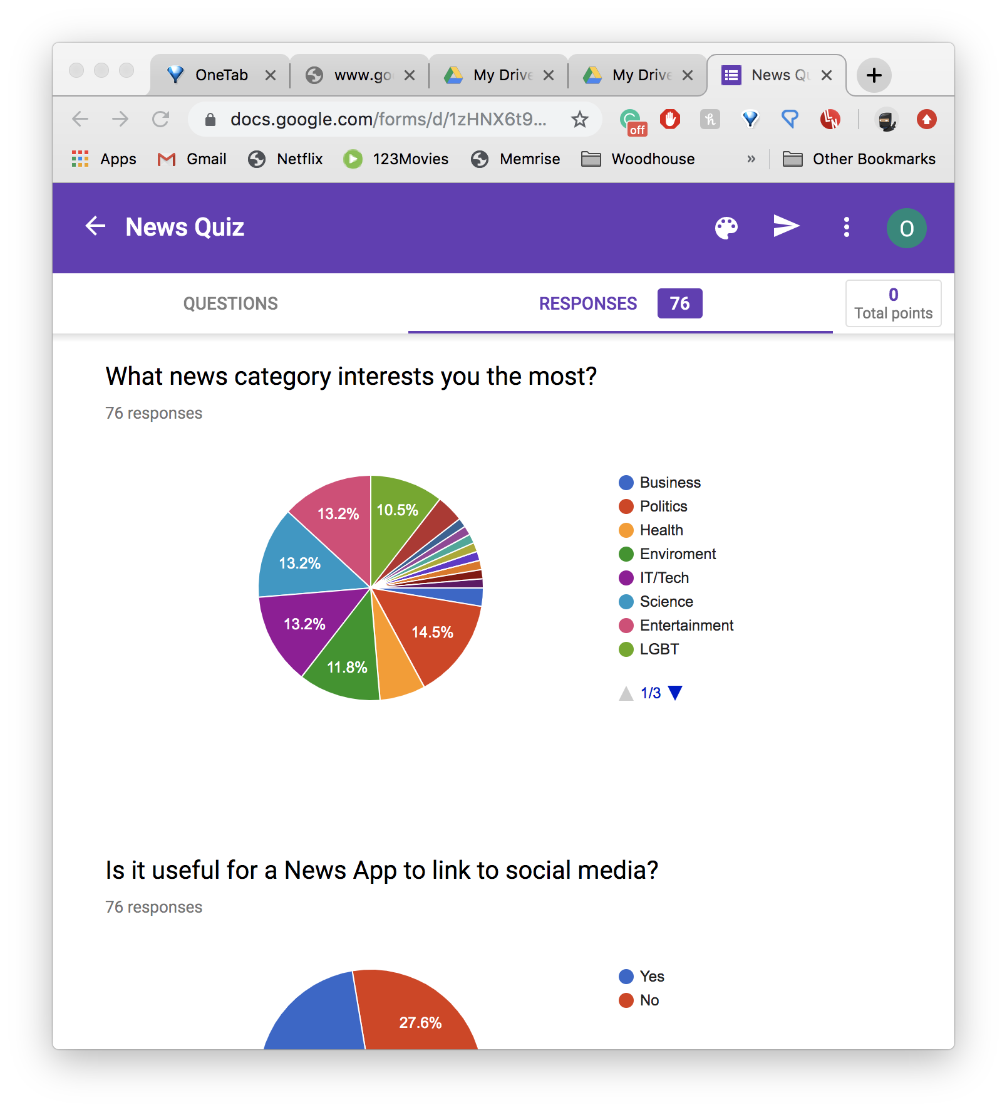

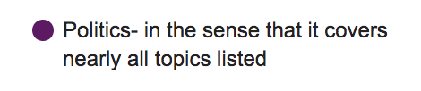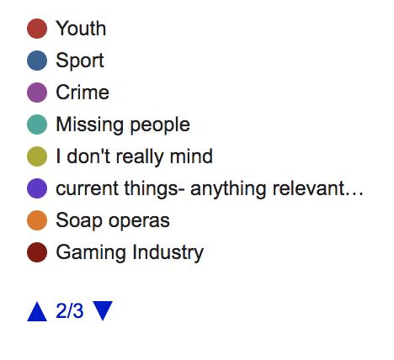

The following results were again quite disorganised, therefore I had to recreate a pie chart to have a more accurate distribution to the popularity of each category.

After sorting out my data, it was clear to see that the most popular categories were: Politics and Entertainment with 16%, Science and Tech with 13%, Environment and LGBT not far behind with 12% and 10%. On the other hand, the youth category did very poorly, with only 3%, same as Business, and Other (Crime and Sports). This therefore means I must consider eliminating those categories from my possible categories.

**What method of presenting information do you prefer?**

Finally, I needed to finalise my decision on the GUI. This question was created to see what GUI would be more suitable for news presentation and whether I should use a more standard table method like most other news apps or whether it is better to go for an original idea of a word cloud.

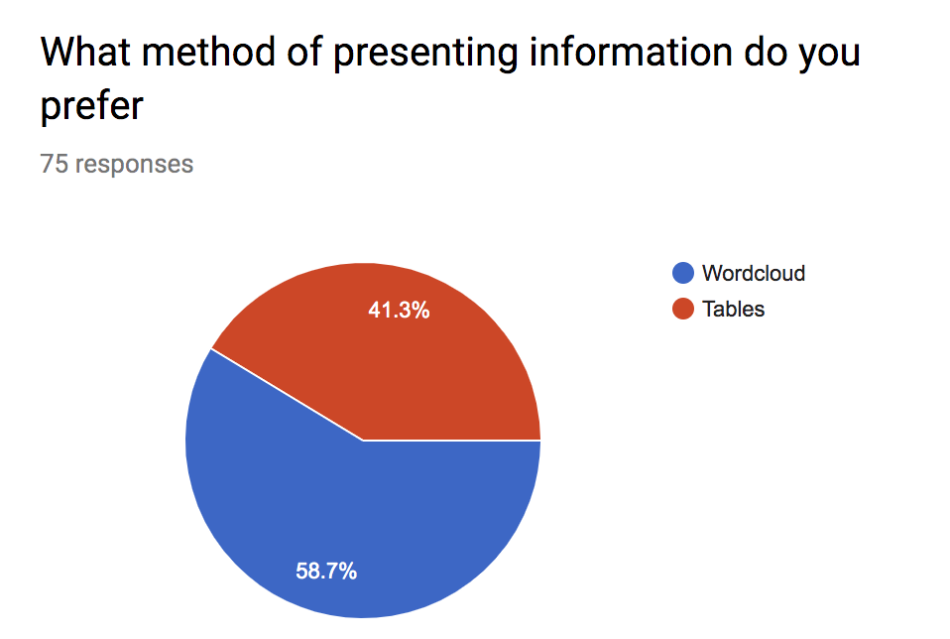

The feedback was close, but the majority were intrigued by the wordcloud idea and were curious to see how news can be represented using a words cloud. This therefore means that I will use a wordcloud idea, similarly to BBC News sometimes, instead of using a normal table idea for my project, like Google News, Tweet Deck and most news services.

Categories:

After analysing my questionnaire, and viewing the most popular categories for other platforms, I have decided upon my categories:

1. Politics
2. Health
3. Environmental
4. IT/Tech
5. Science
6. Entertainment
7. LGBT
8. World
9. UK

I attempted to be more original with my categories and include ones that are rarely thought of like LGBT and Environmental. This was done to appeal more to the younger public and promote awareness and inclusion and to stand out against other news platforms

**Naive Bayes Algorithm:**

To categorise the news into my wanted categories, I must use a machine learning algorithm.

The Naive Bayes Algorithm, which I discovered on Sci-Kit learn, is an algorithm used for classification, that is extremely fast compared to other classification algorithms. I chose to use this algorithm because of its efficiency, accuracy and suitability for text classification, making it perfect for headline categorisation. When given a labelled data set, each instance containing headline and an assigned category, the algorithm uses the Bayes theorem to work out the probability of each word being used for each category. The algorithm assumes that each trait of a class (a word) is independent and unrelated to all other features so all features independently contribute to overall probability. This algorithm often outperforms more sophisticated methods. It uses the following formula for classification:

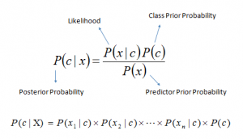

First of all, the data fed to the algorithm must be normalised and vectorised. Normalised, means removed punctuation converting words to lowercase. Vectorised means all unique words across all headlines are given a unique integer number, each category is also given a unique number. Each headline is coded as a vector, a long list of integers of the same size (the total number of unique words). Each position contains the number of occurrences of the corresponding word in the headline. The resulting two-dimensional array of headline vectors ( X axis value) and corresponding labels ( Y axis value) need to be split into training (80%) and test (20%) sets. The X-train and Y-train are then used as a training set for the algorithm. The trained model (a grid of learnt probabilities) is then tested against X-test and Y-test to compare predicted labels with real labels and calculate the accuracy of prediction.

Overall Advantages:

1. It performs well with multiclass predictions
2. Can perform better than logistic regression
3. Needs less test data than most logistic algorithms.
4. Easy to understand and learn

Overall Disadvantages:

1. Is assumes all features are independent when in real life nothing is truly independent
2. All data must be vectorised and converted into numbers
3. If new categorical variable/feature is seen in test data without existing in the training data, the model will be unable to make a prediction and would assign zero probability.

**Verdict:**

The Naive Bayes Algorithm would fit perfectly for my task of categorising news, due to its efficiency, and logical simplicity. I was unable to create my own algorithm for classification because I was unable to get right variety of statistical knowledge, to be able to create an algorithm will this complexity and efficiency, due to the need of very extended mathematical knowledge, however, I have dug deeply into the low end functionality, and I have gained good understanding of how it works and how to effectively implement it.

**Jupyter Notebook:**

I will use Jupyter Notebooks that is a client-server application which allows editing and running Python code in a web browser. It integrates nicely with a lot of Data Science tools. For example it can display Pandas dataframes (in-memory data table), can visualise data with graphs and plots and it is interactive – you can execute Python code one step at a time and inspect the results. We will only be using Jupyter Notebooks to train machine learning model for news categorisation, but the actual program will be developed using Visual Studio.

Using Multiple Sources:

To use multiple sources as I planned, I have to use an API service to get all news headlines and source from, and to use as test data for my model.

**APIs:**

I will be using a news API service called “newsapi.org” instead of directly taking news from chosen sites, e.g. BBC New. Using a News API is more efficient because it aggregates news from different news agencies around the world and in different languages and more data available for training my model.

This service provides me with a wide range of features including, given categories (which I will not use but do myself using machine learning), country, source, language, author, title, publisher, content and description. I will be using the country feature for geographical filtration of news, by using your current location compared to the country of news origin. I will also be using the title as the headline, the url and the source/ news agency for an internal link.

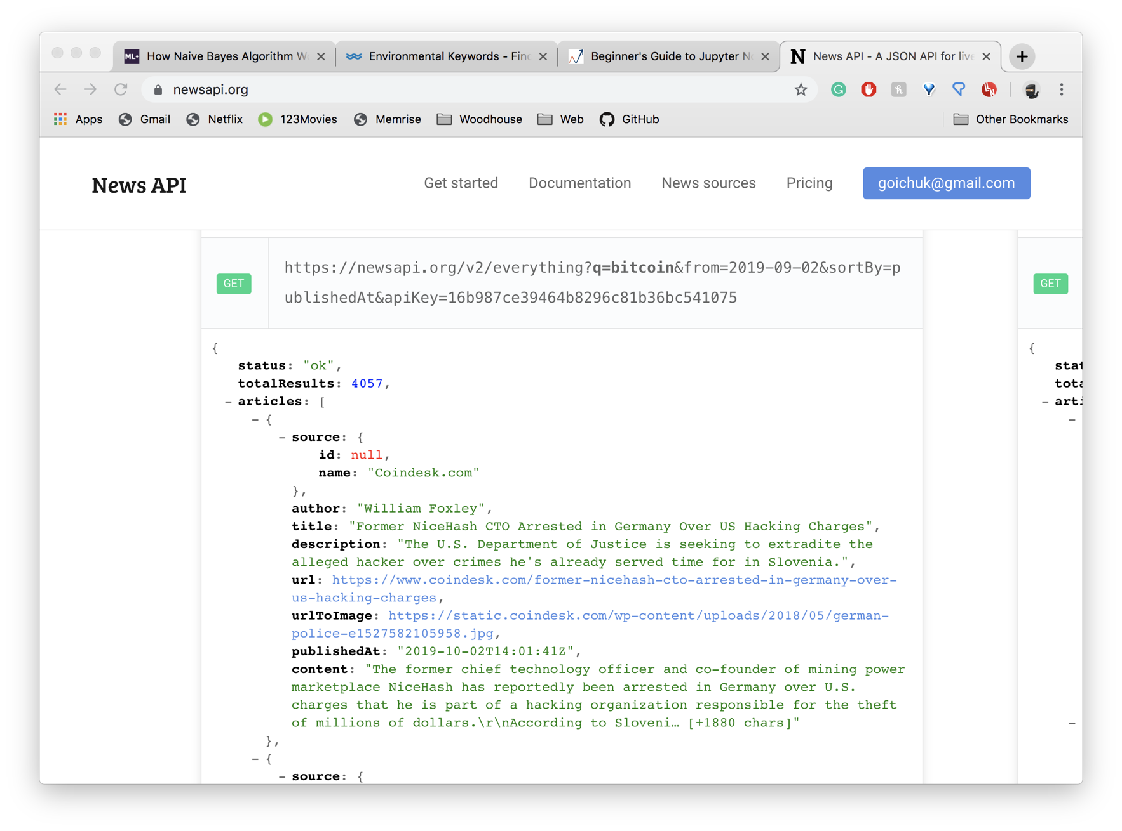

Screenshot from NewsApi showing the structure of data

Improved Classification:

To improve my classification methods, I am also planning to use topic keyword queries to classify news into categories to add an extra level of accuracy and effectiveness. I will use keyword files associated with a topic to classify headlines by checking what key terms the headline consists of. This is done also to make up for the fact that I was unable to create my own algorithm for classification, due to its complexities.

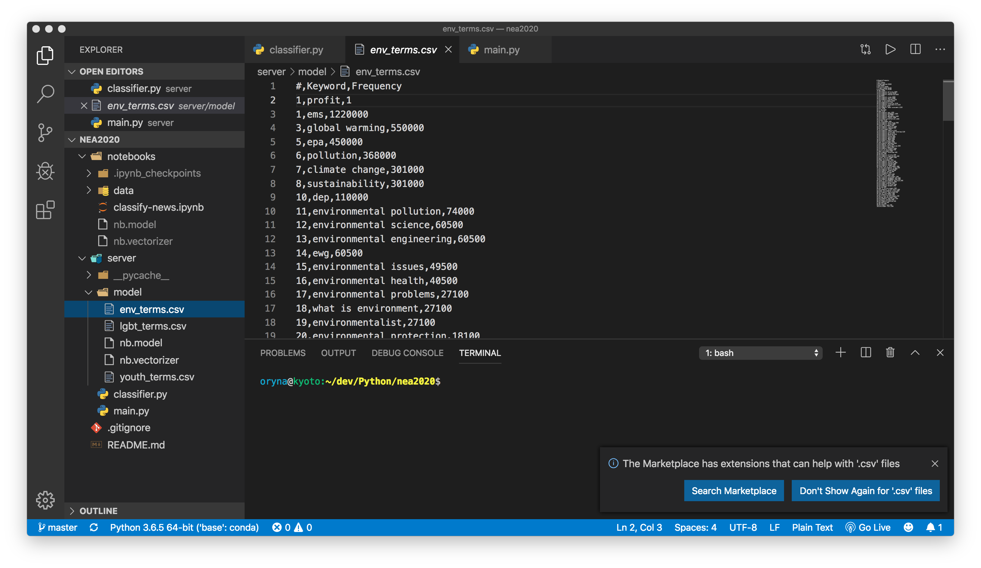

This is the environment keywords csv file that will be used for extra query headline analysis. The keywords list for the environment was downloaded and edited and the lgbt category keywords were created fully from scratch containing about 100 words. To make my categorising more efficient, will create an algorithm that also accepts two-grams and three-grams not just one word, so the algorithm will not only track the presence of one word but up to 3 words.

WordCloud:

After analysing my questionnaire and deciding to use a wordcloud for my layout GUI, I did research and planning into how my GUI must work.

All news events will be displayed in an event headline wordcloud, with the most talked about news story shown in a larger font. The filtering of the word cloud can be changed, from the most popular stories locally or globally.

An Example of a 2008 News Wordcloud:

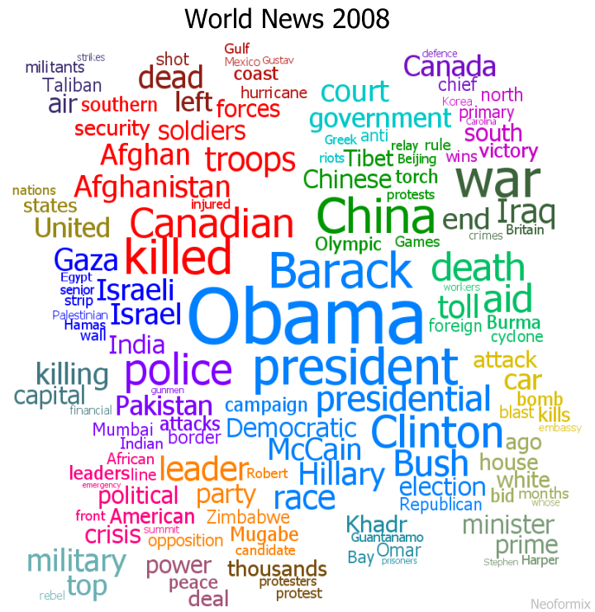

Image Taken from Neoformix: World News Clustered Word Cloud

By Jeff Clark

The graphic above shows a Clustered Word Cloud for the world news headlines from 2008. There are several groups of keywords, each in a different colour, depending the severity of the news story. The second largest (in red) which shows there was a lot of coverage about Canadian soldiers killed or injured in southern Afghanistan. The largest cluster (light blue) shows that the US presidential campaign received a lot of coverage.

____ will use a similar wordcloud to help the user to have an easy interface for quick news reading and finding, that does not include having to scroll through multiple web pages to find desired news. This will allow the user to take in all desired news immediately after observing the image.

Clicking on the headline will direct you to a different page with a complied summary of the event that is created by analysing most popular news stories and links to original articles and sources. This will help to avoid clickbait as only the most repeated words will be used in the headline and all other words of irrelevance will be extracted.



Taken from alamy: Facebook concept word cloud background

The WordCloud above provides a better design for the wordcloud that is easier to breakdown by eye. It uses the most popular Facebook concepts to map the wordcloud. _____ will incorporate social media into its algorithm of finding the most popular stories by counting the number of retweets each story receives and by finding the most popular concepts in Twitter. To attempt to avoid fake news and bias, we will also use Twitter to detect stories with good responses by looking at relevant hashtags, evaluating comments and counting likes.

Self-Generating Headlines and eliminating duplicates:

To generate short, one or two worded headlines, we will use the following natural language processing techniques: stopwords elimination and named entity recognition. After putting news into topic categories, we will find the most important words in each headline by eliminating stopwords (filler words, pronouns, adverbs, article, etc), and counting the number of occurrences of the rest of the words, After I will also apply stemming and lemmatisation to convert each word into its base from (present tense, singular) and by applying names entity recognition, we will be able to detect names, geographical locations, company names etc.

After detecting the most relevant words, I will find headlines with similar relevant word occurrences to group these headlines to be describing the same event. The named entities and most common words in all headlines in a group, will be used to create a word -tag to describe the group event. The following tag will be the headline tag that will go into the word cloud.

This will avoid clickbait as I will only use the most repeated words in each headline and all other words of irrelevance will be extracted, to make the most precise and clear headline

**SpaCy Named Entity Recognition:**

To find duplicates of headlines, to shorten headlines and to normalise text, I will be using SpaCy for language analysis which is a complex library often used in machine and deep learning.

This is an open source libarary that deals with advanced natural language processing. It can be used to understand large amounts of text or text extraction. SpaCy can break up text into words and punctuation marks (Tokenization) can assign words to be nouns, verbs etc (POS tagging), lemmatization (explained above), sentence boundary detection, named entity recognition (what I will be using), entity linking, highlighting similarities and text classification.

SpaCy’s named entity recognition requires the data to be in a csv format, and can classify anything from names, organisations, locations, medical codes, expressions, quantities and values. I will be using it mainly for name and location recognition to strip the most key facts about each headline that I can later compare. It works by comparing words to its list of known named entities, that is very frequently updated. It also does speech parse recognition by analysing words, using speech tagging (e.g. noun, verb) which also lets it know when a named entity is most likely to come up.

Twitter Incorporation:

To connect Twitter to our application, I am going to develop a python application that will be continuously consuming events from twitter using twitter firehose API. The consumed events will be filtered and stored into a database. I will use short generated headline as a hashtag/filter to search for in Twitter, to display relevant Tweets together with headlines. As the number of Tweets, we consume will be huge, I will apply efficient filtration to filter out Tweets.

Filtering News by location:

We will take the location of user in browser (or allow user to choose any location geographically). I will then display a menu where the user can select to only view the news local to them or global (news in their country or city, or any country desired or global with unfiltered location).

Summary of News:

After clicking on the shortened headline in the wordcloud (page 2), you will be displayed the generated summary that I will create by making an algorithm that will summarise the news event. Firstly, we will go to the link of the news proved by newsapi.org and scrape the body of the news. I will exclude all the stopwords (a list of the most common English words and articles) using a list of stopwords, to remove everything that is not unique to the news body. I will next split the text into sentences and for each word, I will build a TF/IDF (term frequency/ inverse document frequency). This will help me find the most relevant/important words in each sentence. I will then filter out and only leave sentences with the highest scoring words using this metric.

**1.3- Prototyping:**

Training Machine Learning Model:

Over the summer I got to use the Naïve Bayes Algorithm to train my model to categorise news headlines into 4 categories.

I used the standard stack for machine learning (helping functions from sci-kit learn) to train and test my model:

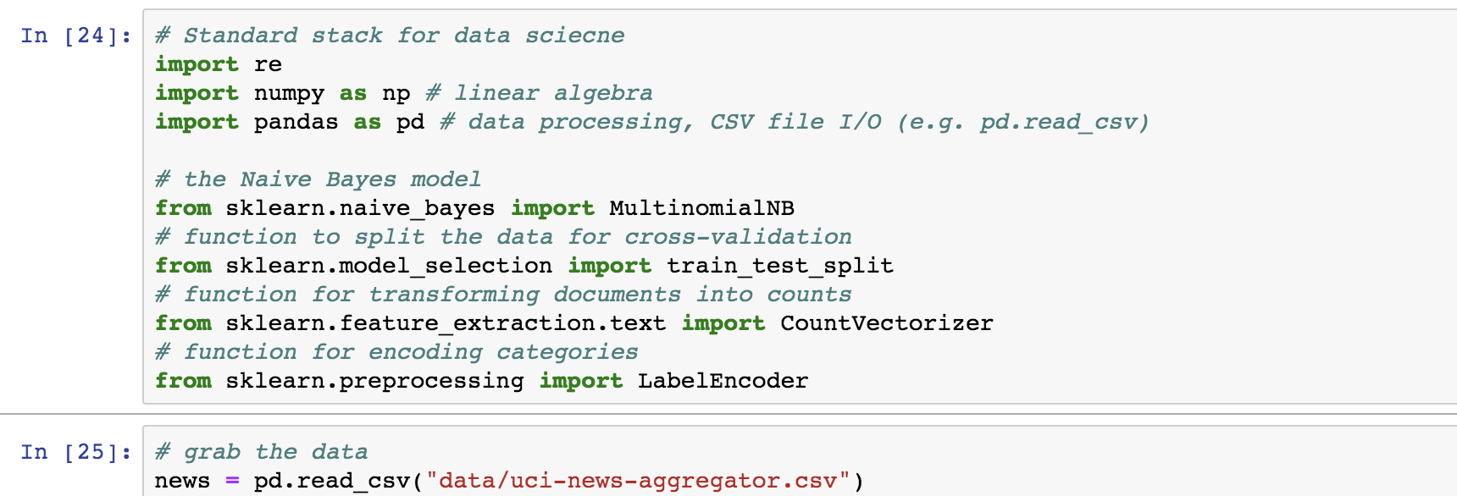

I imported numpy, a library that does mathematical calculations including linear algebra, matrices and vectors multiplication, that is used by the Multinomial Naive Bayes algorithm. It is an optimised array that is used specifically for number calculations, unlike standard python lists.

Pandas is a library that allows you to manipulate with tabular memory data/ lists of records, each column being your numpy array.

The train_test_split helps to split your data set into a training set and a data set (a helper function). You provide the ratio, by which the data is split.

The CountVectoriser function is a common helper method for text processing: turning text into vectors. When given a list of headlines, it finds all unique words across all headlines, which will form a vector space of high dimensionality. After that, the CountVectoriser, turns each headline into a vector in that space, where in each position (word), you have the total of that word repetition in that headline.

The LabelEncoder assigns a number to each unique label to encode each unique category with a number.

**Normalising Text:**

Firstly, to use the data in text processing, we need to clean the data. The data was taken from the News API service (page 16). Cleaning the data meant stripping all punctuation, replacing multiple spacing with one space and converting to lowercase. This must be done to more accurately vectorise the data.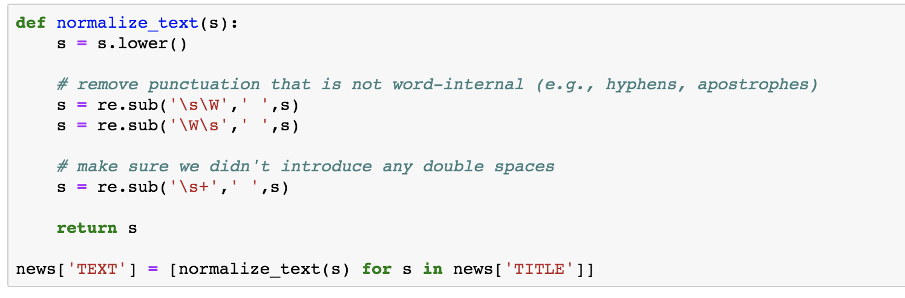

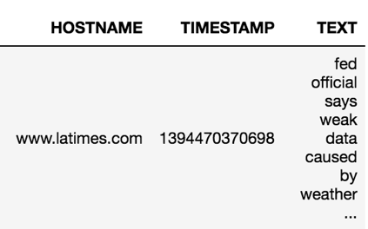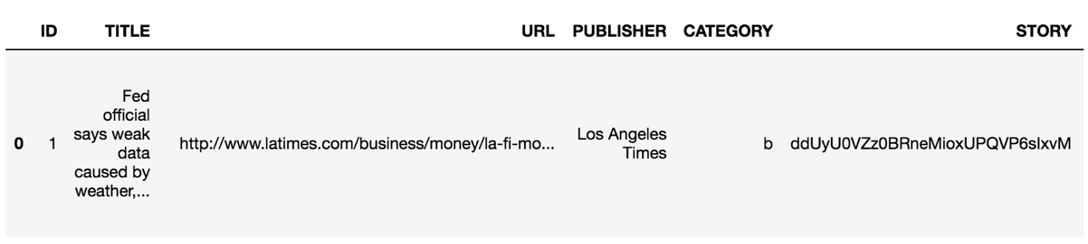Next were showing the pandas dataframe built from csv file:

Where the first column is the original headline and the last in the normalised headline ready to be vectorised.

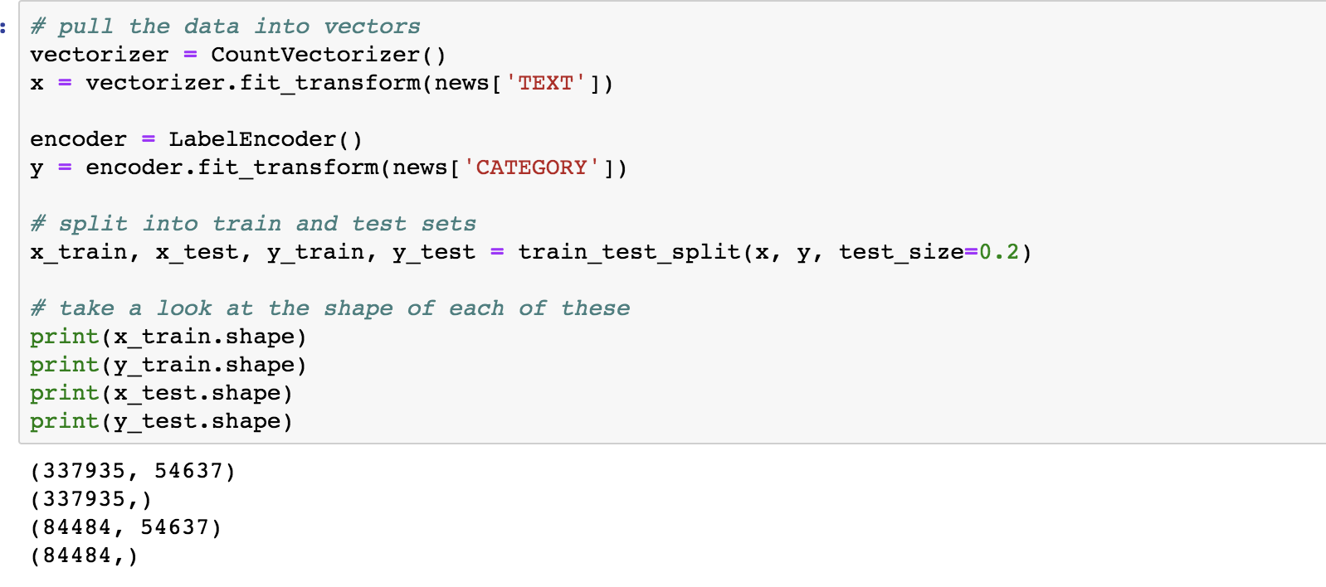Next I vectorised the TEXT column and encoded the category column as a list of whole integers and split the data into a training set and a test set.

When printed, the results outputted is the length of all vectors (number of total unique elements is the length). After our headlines were vectorised, I used the Multinomial Naïve Bayes algorithm to train and test my data, getting a whole 92% accuracy. After this I downloaded my model and vectorizer as a binary file so I then can use my trained model in visual studio.

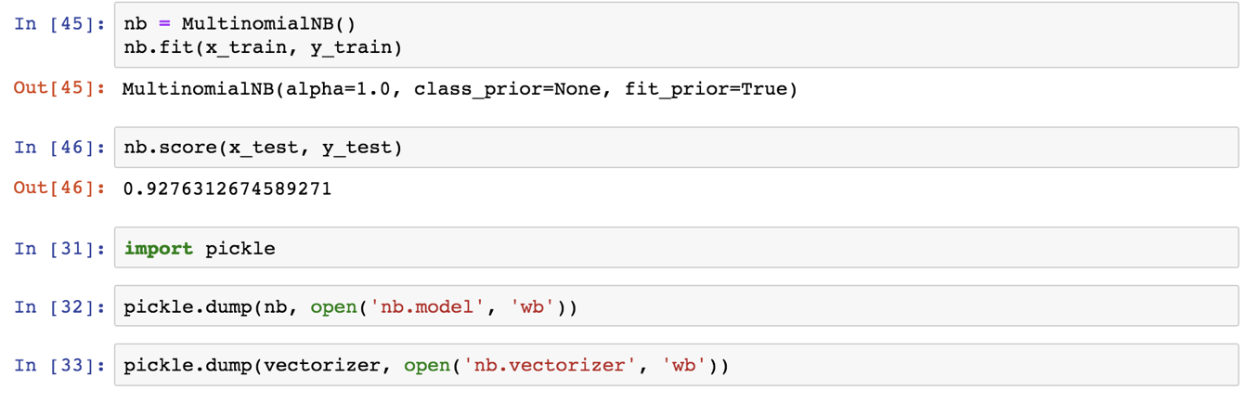**Limitation for the data and algorithm:**

The data I used from NewsAPI could only be split into 4 categories (business, entertainment, health and tech) meaning that I will need to categorise other categories through queries or use a different set of data. NewsAPI also only refreshes its news stories evey 15 mins, not very efficient for my news site.

The Algorithm can also classify the news into categories, but it cannot detect whether 2 news stories are written about the same event, therefore I will need to design my own algorithm and use natural language processing to define whether 2 headlines by different agencies are written about the same event.

The accuracy also can be higher than 92% is more test data is used but as it is extremely difficult t find a large amount of testing data, I must settle for 92%.

Another limitation is that all data must be normalised and vectorised to be efficient, as without normalising the headlines, the same word written in lower and upper case would be considered a different word.

**1.4 – Overall Limitations & Proposed Solutions:**

**Access to real time news:**

The main limitation is that each news agency provides data in its unique format, which means either a connector must be built for each agency to represent their information uniformly for the rest of the application or using a service that aggregates it for you (like newsapi.org) but in my case, it only provides headlines not the rest of the body. It provides a link to a news article web page. I will have to scrape news body from the web page, which is not a guaranteed process. I will only work with a selected number of news agencies.

**Not enough labelled datasets for categorisation:**

There is no labelled dataset with the list of categories that I want to use, so I need to use a labelled dataset I found that is publicly available and algorithmically detect the rest of the categories or use multiple data sets for training, but it will make it less accurate. I have used the largest dataset I found with 400,000 headlines; however, the dataset was created in 2014 meaning that any new words since (e.g. BREXIT) are not known to our model. The problem with labelling algorithmically is that it is restricted to hard coded rules that I provide, which is not very flexible, however we used bigrams and trigrams to make our algorithm as flexible as possible

**Summarisation is an open problem:**

There is no efficient algorithm that can summarise any text, and it cannot be created. Anything used is an approximation of human level summarisation. I am going to attempt to create a basic algorithm for summarization that might not generalise for all kinds of texts. Summarisation across multiple documents is harder because each document uses its own vocabulary to describe the same event.

**Social Media – too much of it:**

The number of Tweets per second is in millions; to process them efficiently, I need to filter them first by news related hashtags, geographical locations and other ways which risks losing valuable information. Another solution is to have a huge cluster of machines to process all Tweets.

**Naïve Bayes Algorithm limitations:**

It is very fast in training, which is why I chose it, but it has limited predictive power because it only considers the presence of particular words in headlines, but not their order. There are better predictive algorithms like BERT (from Google) or GPT2 (from Open AI). These are deep learning algorithms that require specialised GPU hardware to train on it, which is paid for in the cloud. They also require much more labelled data than I found to be freely available.

**SpaCy Named Entity Recognition knowledge base:**

The list of known entities might be outdated therefore some important proper nouns can be missed out leading to unclear headlines and results. I can compile a list of the most recent trends to check against as well as using the algorithm.

**Multiple Technologies:**

The application consists of multiple parts, each using a different technology, including machine learning tools, stream processing tools, web scraping tools, web server, and in-browser web application that users will interact with. I have a very limited amount of time to learn them all deeply, therefore I might not use them in the most efficient way.

**1.5 – Overall Objectives & Proposed Solutions:**

Overall Objectives:

1. Provide 9/10 topics for news sorting that the user can choose from on the site.
2. Have an algorithm this automatically groups together the same news stories from different agencies using machine learning.
3. Create a news header wordcloud that will contain the most popular news (depending on how many news agencies produced the following news story) that are ranked based on the size of the header font.
4. The filtering of the word cloud can be changed, from the most popular stories locally or globally.
5. The headlines will be self-generated; an algorithm will count the frequency of each word used in the same news story across different news agencies. The Subject of each news story will be identified (person or place). The self-generated headline will contain the subject and the action in the story (based on the most frequently used words to describe the story). (page 19)
6. Clicking on the headline will direct you to a different page with a compiled summary of the event that is created by analysing the most popular news stories and links to original articles and sources.
7. Avoid clickbait by only using the most repeated words in each headline and all other words of irrelevance will be extracted. (page 20)
8. Incorporate Twitter into sorting the most popular news stories (based on the number of retweets) and use the comments and likes to evaluate which news stories are liked by the public, therefore attempting to extract fake news.

In-depth Objectives:

1. Use a news API to get all current news. The API provides headlines (not the rest of the body) so I will use the link that is provided to the original news article web page scrape news body from the web page when creating my summary.
2. Create the summary by using natural language processing by excluding stopwords and building a TF/IDF (term frequency/ inverse document frequency) to find the most relevant/important words in each sentence. I will then filter out and only leave sentences with the highest scoring words using this metric for my summary.
3. Use the Multinomial Naïve Bayes algorithm to automatically sort the news into categories. I will also layer an extra layer of categorisation to add extra categories to my news site.
4. I will use a vectorizer and a normaliser to normalise and vectorise text to be ready to be trained by my machine learning model. I Will train the model in Jupyter Notebooks to split news into 4 categories.
5. I will use an API to access real time news that will refresh multiple times during the day.
6. I will incorporate Twitter into my site. I am going to develop a python application that will be continuously consuming events from twitter using twitter firehose API. The consumed events will be filtered and stored into a database. I will use short generated headline as a hashtag/filter, as well as geographical locations to search for in Twitter, to display relevant Tweets together with headlines.
7. I will use multiple different agencies for news sorting.
8. I am also planning to provide news from many geographical locations like Google News where you can view UK news, Global and anywhere else (page 20).
9. Additionally, I will cut down filler from headlines to make them more to the point and decrease information overload using SpaCy (page 19).
10. I will provide an easy to use GUI with a word cloud using html and css.
11. I will try to eliminate fake news and clickbait by using feedback from Twitter and only leaving out the key words in every headline. I will also use multiple sources about the same event to generate headlines and summaries to make it more reliable.
12. I will create large key term cvs files for adding extra categories and for named entity recognition
13. I will provide a link to each original page from the summary page I have created.
14. I will test my site on a public age 17-40 to get feedback on my site.